PROMETHEUS V2.0 FUNCTIONALITY AND APPEARANCE
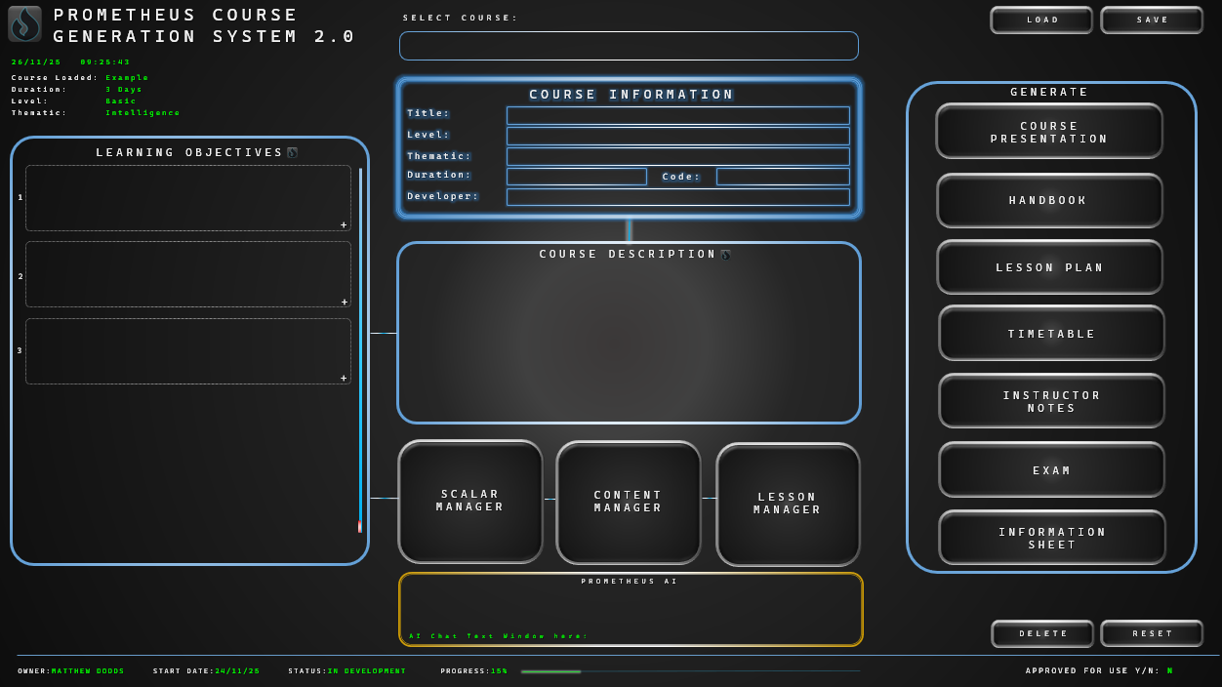
- IMPORTANT: The visual appearance, layout, and styling of the UI should follow this mockup as closely as possible.
UI FUNCTIONALITY DESCRIPTION
- Flame Logo and Title Label – fixed in top left. Logo is available here: "C:\Users\matt_\OneDrive\Desktop\PCGS\PCGS\assets\prometheus_logo.png"
- Top Left information cluster (top left) shows the Date, Time, Course Loaded, and other course details. This is read – only.
- SELECT COURSE window – a drop down menu, listing previously saved courses (courses should be saved locally for now, possibly Cloud storage in the future).
- LOAD and SAVE buttons (top right): LOAD will load the course selected from the SELECT COURSE menu. SAVE will save the current course being worked on within the Prometheus System. These buttons, along with the information cluster (and the DELETE and RESET buttons, and the bottom information bar) should be present throughout the system (the UI will have more than one page). The LOAD button, however, will only be available to press on the first page of the UI.
- COURSE INFORMATION
  - The glowing border indicates that the window is active. It should stop glowing when another window is active (which should have a glowing border).
  - Title, Level, Thematic, Duration and Developer are mandatory – once these are completed, the window will be in a ‘Completed’ state, and the single line connecting this window to the COURSE DESCRIPTION window should glow.
  - Title is manual entry (all windows should auto populate when a course is selected from the SELECT COURSE menu).
  - LEVEL and THEMATIC are drop down menus.
    - LEVEL – Foundational, Basic, Intermediate, Advanced, Expert, Senior. These levels need to be defined properly as they should inform any AI – generated content.
    - THEMATIC – Defence & Security, Intelligence, Policing, Crisis Response, Resilience, Leadership, Personal Skills (editable via Admin functionality, which will be defined later).
  - DURATION: Numerical, manual entry (defines the length of the course in days. Should accept half day values).
  - DEVELOPER: Manual entry (developer’s name).
  - CODE: Manual entry, non-mandatory, does not affect other functions.
- COURSE DESCRIPTION
  - Manual entry, free text which describes the purpose of the course overall. Descriptions will vary in length, but usually no more than 100 words (average between 50 – 70), and can occasionally be split into multiple paragraphs.
  - This window will be come active (i.e. the borders will begin to glow) once the user begins typing inside it, or presses the small flame logo (the COURSE INFORMATION border will stop glowing at that point).
  - The small flame logo should activate the ‘PROMETHEAN KNOWLEDGE ENGINE (or PKE)’, an embedded AI which will assist in course development (this will be build later). On pressing this flame logo (or any other flame logo within the UI), the gold box at the bottom of the UI should glow, indicating the PKE is active.
    - In this window, the PKE’s introductory message is: ‘Hello [insert Developer name]. I am ready to describe the course. Are there any other details you wish to tell me before I do so? If not, press N and I shall proceed’ (PKE buttons should not be active until the COURSE INFORMATION window is complete).
    - The PKE will then provide a Course Description (text should appear in the COURSE DESCRIPTION window), and ask the user (with text appearing in the PKE gold box): ‘Please review the Course Description. If you approve, press Y. Otherwise, press N for an alternative description. Your comments are also welcome’ (if the user comments, the PKE will consider this in their next response).
    - If the user approves, the PKE window will cease glowing gold.
  - Example course description (FYI): This foundational course introduces participants to the challenges and opportunities created by AI in modern conflict. It explores how autonomous systems interact with the core principles of International Humanitarian Law and examines accountability, control, and ethical risk through concise lessons, real-world examples, and an interactive scenario.
  - The COURSE DESCRIPTION window is considered ‘complete’ once it contains more than 20 text characters. Once it achieves a completed status, the line connecting this window to the LEARNING OBJECTIVES window should glow.
- LEARNING OBJECTIVES.
  - Manual entry, or auto generated by the PKE (activated by pressing the small flame logo).
  - May contain up to 10 Learning Objectives (aka LOs, or CLOs), with maximum of 5 shown in the window (more than 5 and the vertical slider bar on the right hand side of this window can be used).
  - The small + button will add a new LEARNING OBJECTIVES window.
  - Learning objectives will be free text, varying in length, usually around 5 – 10 words.
  - Learning Objectives always begin with a ‘Blooms Taxonomy’ performance verb. Regardless of how the user enters text, the first word should automatically be capitalized. If the first word is not a Blooms Taxonomy performance verb, the Learning Objectives box should briefly glow red, and a warning message appear at the bottom of the window which says ‘Use Blooms Taxonomy Performance Verbs’.
  - If the user activates the PKE (by pressing the small flame logo), the PKE window will glow gold, with the PKE message as follows:
    - ‘Generating Learning Objectives – please review and confirm acceptance by pressing Y. If you require alternatives, press N’. (if the user presses ‘N’ the PKE will then ask which LO requires alteration, and ask for user input).
  - Learning Objectives window borders should glow when active, and will be considered complete once ONE Learning Objective has been entered (completion status indicated by the small horizontal wire connector joining it to the ‘Scalar Manager’ button beginning to glow).
- SCALAR MANAGER, CONTENT MANAGER, LESSON MANAGER buttons – all currently placeholders: they will each open up a separate page of the UI, to be designed. Brief functionality is:
  - SCALAR MANAGER: The ‘Scalar’ lists the course Learning Objectives, Topics, Sub Topics, Lesson Titles and Performance Criteria for the course; these items are given linked serial numbers (i.e. CLO 1, Topic 1.1, Sub Topic 1.1.1, Performance Criteria 1.1).
  - CONTENT MANAGER: To help organize and allocate manually gathered content for the course (text, articles, links, video etc).
  - LESSON MANAGER: For building individual lessons, based on the topics and subtopics as per the Scalar.
- GENERATE. This window contains various export buttons: pressing them will bring up a sub menu asking for format requirements, and then automatically generate the relevant course material.
- PROMETHEUS AI
  - The interface area for users to interact with the PKE. It will glow gold when active (when a small flame icon is pressed somewhere in the UI). Outputs from the PKE (i.e. Course Description, Learning Objectives etc) will appear in their relevant window, with PKE responses appearing in the Prometheus AI window itself).
- FORMATTING TOOLS: Links to a page which gives the user various options for formatting / reformatting Course materials.
- TEMPLATE MANAGER: Links to a page where Course Material templates can be imported, mapped, edited and saved.
- DELETE & RESET
  - DELETE: Deletes the currently selected course and all associated data with it, entirely. Pressing should bring up a confirmation message ‘YOU ARE ABOUT TO ERASE THIS COURSE. ARE YOU SURE? Y/N’. The DELETE button is only active on the first page of the UI (greyed out, along with the LOAD button) on subsequent pages).
  - RESET: Clears the UI of all data, but does not erase saved data (resets the UI to it’s default state on launch).
- BOTTOM INFORMATION BAR: Read only – displays:
  - OWNER: Developer Name
  - START DATE (the date when the course was first saved),
  - STATUS (OPENED, IN DEVELOPMENT, AWAITING APPROVAL),
  - PROGRESS: A glowing bar which extends (and a numerical indicator) of development progress; percentage will be calculated as a function of progress throughout the development workflow.
  - APPROVED FOR USE Y/N: indicates whether or not the course has been approved via external accreditors.
The various exports will follow proprietary formats according to the organisation who is using the system.
The system is designed for multiple users, who may either use a local version on individual laptops, or cloudbased. User Logins will be required, and an Admin login option.
Data security is also paramount and should be considered throughout the build.
The system has already had progress done; code is saved in Github, and you already have access to that repo.
You should seek clarification at any stage of the build, and you should run an up to date Project status list, which indicates what functions are available, what are to be built, and any unresolved issues. You should also give me very clear, step by step instructions for anything you require me to do (I do not code, and am unfamiliar with a lot of coding terms).

